**Secure Internet gateway**

Download and Installation process of Secure Internet gateway.

**Step 1:** First, please check antivirus install or not and proper working or not.

**dpkg --get-selections | grep escan.**

**Step 2:** Install git package for access git repository.

**cd Music/**

**sudo apt-get install git -y**

**Step3:** Copy Prisma directory from GitHub repository

**sudo git clone** [**https://github.com/jenkinstudent/prisma**](https://github.com/jenkinstudent/prisma)

**Step4:** Move to Prisma Directory and check open long list of directories or files.

**cd prisma**

**ls -l or ls -lrt**

**Step5:** Grant permission to execute shell script file (Mint_Script.sh).

**sudo chmod u+x Mint_Script.sh**

* permission has been granted, please check given below screenshot for your reference.

**ls -l or ls -lrt**

**Step6:** Execute shell script for installation some application and dependencies on Linux OS.

**sudo bash Mint_Script.sh**

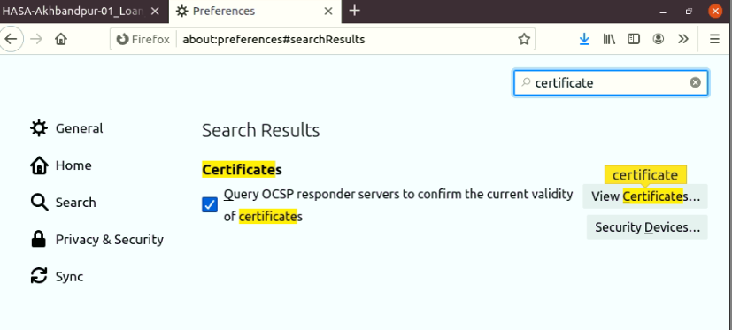**Step7:** Import Certificate in Mozilla Firefox Google chrome and Thunderbird, Given below screenshot for your reference.

**Step8:** Finally install Globalprotect Debian file.

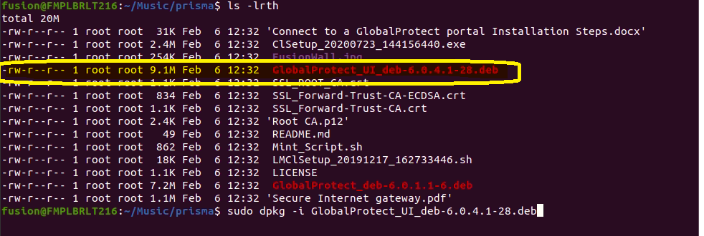

**sudo dpkg -i GlobalProtect_UI_deb-6.0.4.1-28.deb**



**Step9:** Connect Globalprotect with given credentials.

FQDN: **fmpl.gpcloudservice.com**

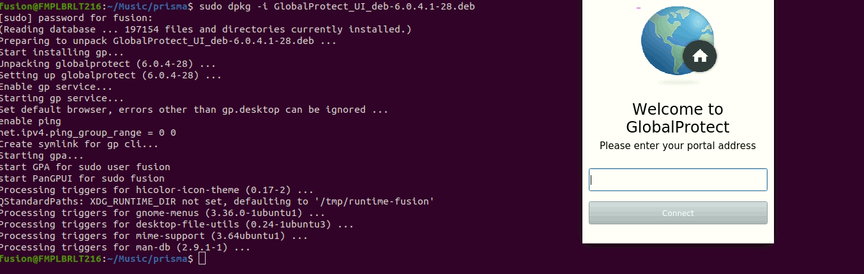

Step 10 : Add to Task Manager



Step 11: Enter SIG LoginID and Password

**Note:** Ubuntu 19 and above anydesk dependency remove using given below script.

**sudo sed -i '7 s/^#//' /etc/gdm3/custom.conf**